**2022 B Answer**

# **Q1:**

**Q2:**

**Q3:**

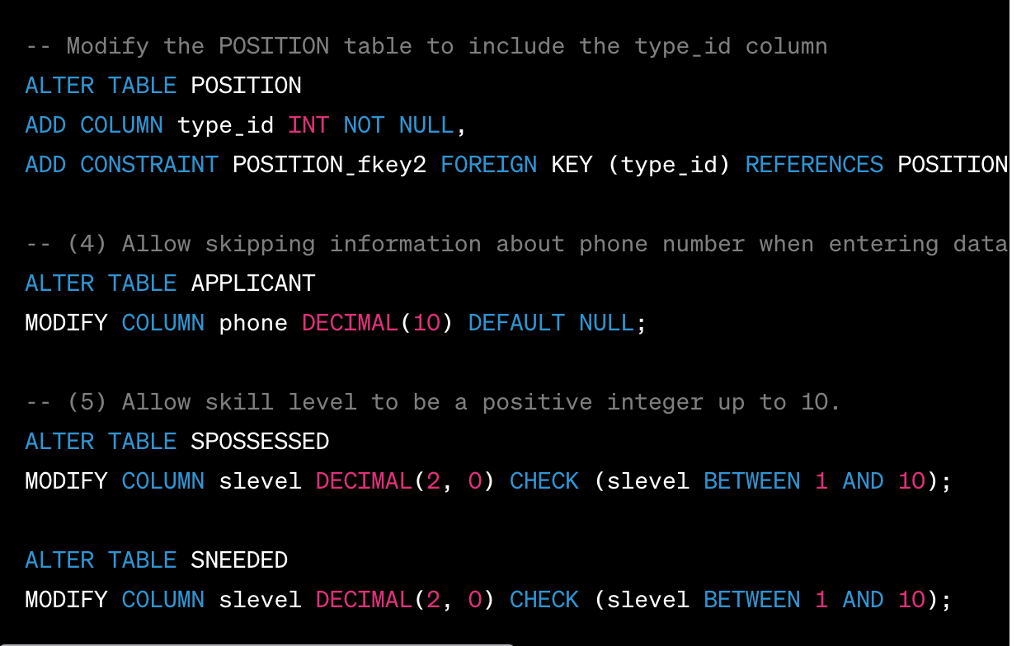

**Q4:**

1. **Insert into APPLIES Values ( 7, 21, Curdate());**
2. 
3. **A close up of black text

   Description automatically generated**
4. **A close-up of a white background

   Description automatically generated**

**Q5.**

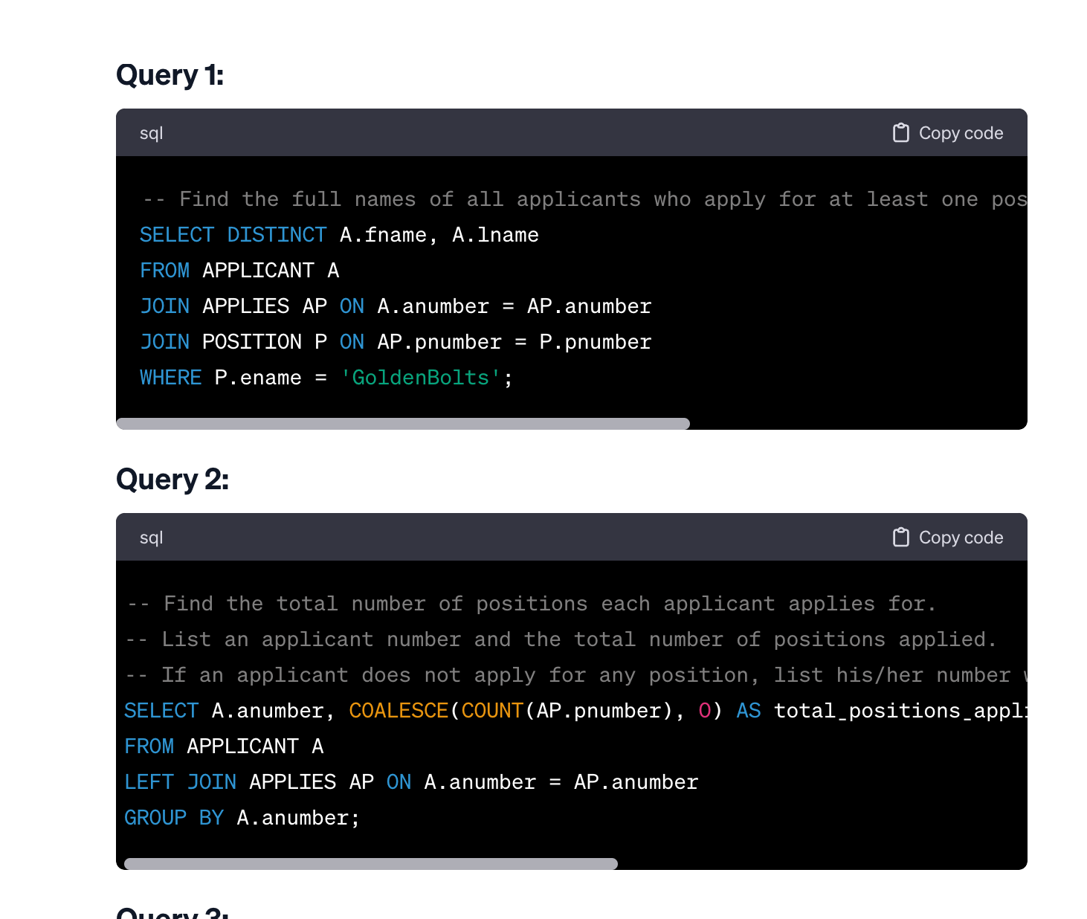

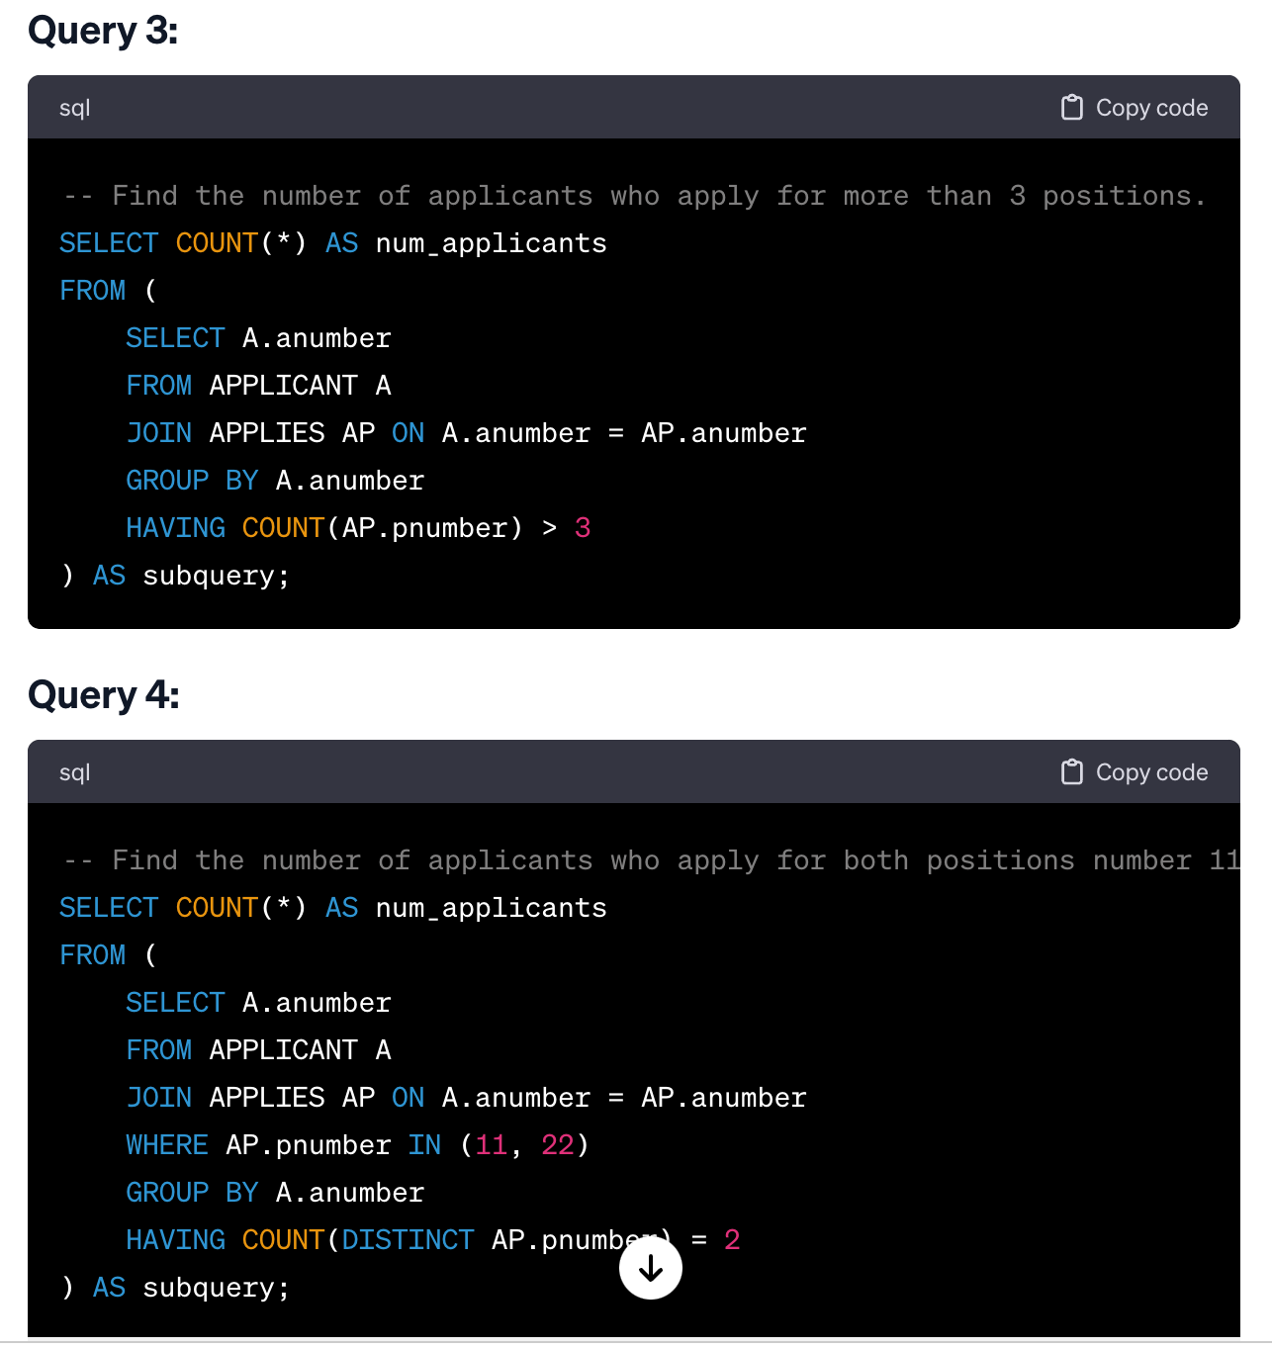

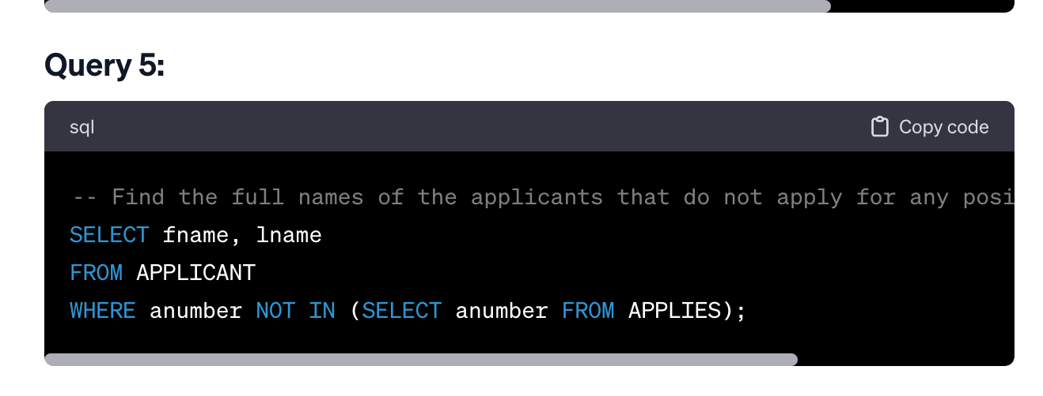

**Q6:**

SELECT

A.anumber,

A.fname,

A.lname,

'has submitted more than 3 applications in one day' AS violation_message,

AP.appdate AS violation_date

FROM

APPLICANT A

JOIN

APPLIES AP ON A.anumber = AP.anumber

JOIN (

SELECT anumber, appdate, COUNT(*) AS total_applications

FROM APPLIES

GROUP BY anumber, appdate

HAVING COUNT(*) > 3

) AS Violations

ON

A.anumber = Violations.anumber AND AP.appdate = Violations.appdate;

**Q7:**

